An in-depth guide to Decision Trees

1. Introduction to Decision Trees:
Decision Trees are among the simplest yet most effective supervised machine learning algorithms. They are versatile tools for both classification and regression tasks. By splitting data based on feature values, Decision Trees mimic human decision-making processes, offering easy-to-understand visualizations and predictions.
How Decision Trees Work:
- Root Node: Represents the entire dataset. The algorithm chooses the feature that best splits the data into subsets.
- Decision Nodes: Represent splits in the dataset based on thresholds for a given feature.
- Leaf Nodes: Represent final decisions or classifications.
Benefits of Decision Trees:
- Interpretability: Each step of the prediction process can be easily visualized and explained.
- Non-linear Boundaries: Captures complex patterns without requiring extensive feature transformations.
- Flexibility: Handles both numerical and categorical data.
- Feature Selection: Automatically identifies important features during the training process.
Limitations:
- Overfitting: Without constraints, Decision Trees can become overly complex, leading to poor generalization on unseen data.
- Bias to Dominant Features: Features with more splits or higher variance may dominate decisions.

Example Applications:
- Healthcare: Diagnosing illnesses based on symptoms.
- Finance: Predicting creditworthiness for loan approvals.
- Retail: Analyzing customer churn based on past purchase behavior.
Key Metrics:
- Gini Impurity: Measures class mixing at a node; lower values indicate better splits.
- Entropy: An alternative impurity measure based on information theory.

2. Dataset Overview:
Characteristics of the Iris Dataset:
The Iris dataset, a classic benchmark in machine learning, contains:
- 150 samples divided into three classes: Setosa, Versicolor, and Virginica.
- Four numerical features: Sepal Length, Sepal Width, Petal Length, Petal Width.

Why the Iris Dataset?
- Simplicity: Its small size and clear class boundaries make it ideal for beginners.
- Balance: Equal representation of classes ensures unbiased model training.
- Visualization: Petal and sepal dimensions allow for intuitive graphical representation.

Objective:
The task is to classify flowers into one of the three species based on their features. The simplicity of the Iris dataset makes it a perfect choice for exploring and understanding Decision Trees.
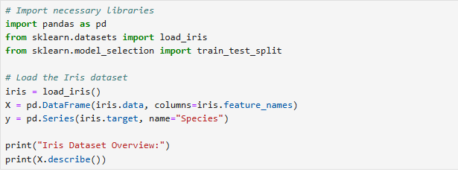
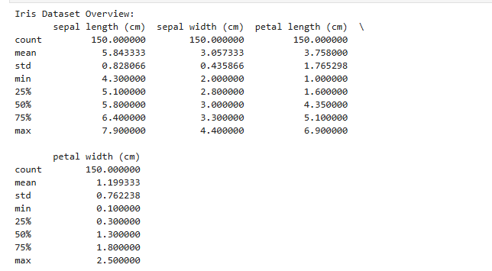

3. Data Preparation:
Importance of Preparation:
Data preparation ensures:
- Generalization: By splitting the data into training and testing sets, the model can be evaluated on unseen data.
- Consistency: Using a fixed random_state ensures reproducibility.
- Balanced Evaluation: Reserving 30% of data for testing provides sufficient data for evaluation.
Steps:
- Load the Iris Dataset: The dataset is loaded using sklearn.datasets.
- Split into Training and Testing Sets: Using train_test_split, the data is divided into 70% for training and 30% for testing.
Code Explanation:
- random_state=42 ensures the same split every time the code is run.
- test_size=0.3 allocates 30% of the data for testing.

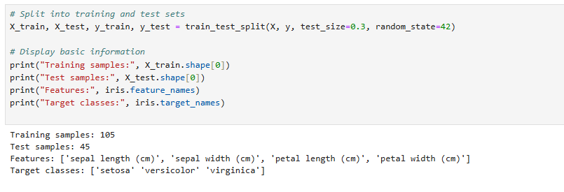

4. Baseline Decision Tree:
Building the Baseline Model:
- A Decision Tree was trained using sklearn.tree.DecisionTreeClassifier with default parameters.
- Default Criterion: Gini impurity was used to measure the quality of splits.
- Initial Evaluation: The model's performance was evaluated using accuracy and a classification report.
Results:
- Accuracy: The model achieved high accuracy due to the dataset's simplicity.
- Class Performance: Setosa was classified perfectly, while some misclassifications occurred between Versicolor and Virginica.
Key Observations:
- Default settings produced a highly accurate model, but the depth of the tree indicated potential overfitting.

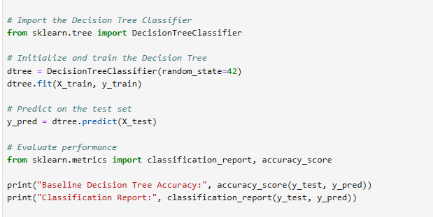

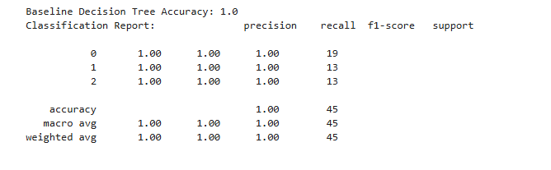
5. Tree Visualization:
Purpose of Visualization:
Visualization provides insights into:
- Feature Importance: Identifying which features are most critical.
- Decision Path: Understanding the sequence of splits leading to a prediction.
- Overfitting Detection: Complex trees with excessive splits can signal overfitting.
Key Insights:
- The root node split on Petal Width, highlighting its importance.
- Deeper splits refined classifications based on Petal Length.
- Leaf nodes represented pure classifications with a single class.

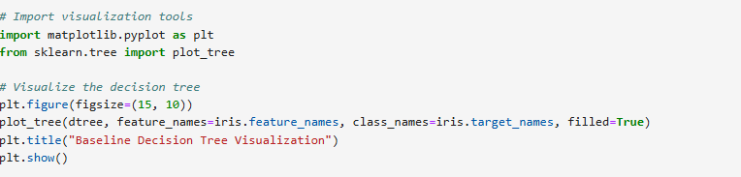

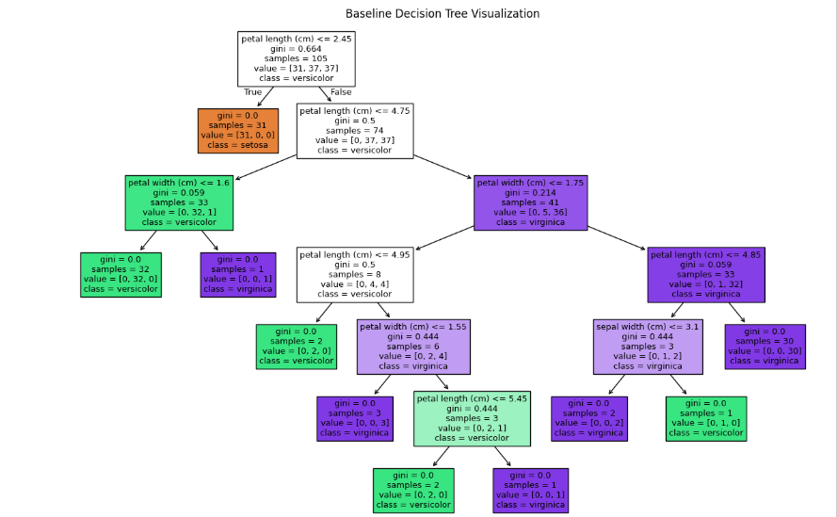

6. Feature Importance Analysis:
Method:
Feature importance was extracted using the feature_importances_ attribute of the trained model. This measures the reduction in impurity attributed to each feature.
Key Findings:
- Petal Features: Dominated the tree, confirming their significance in separating classes.
- Sepal Features: Contributed minimally, suggesting they could be excluded for simpler models.
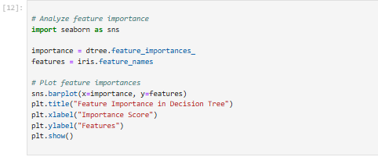
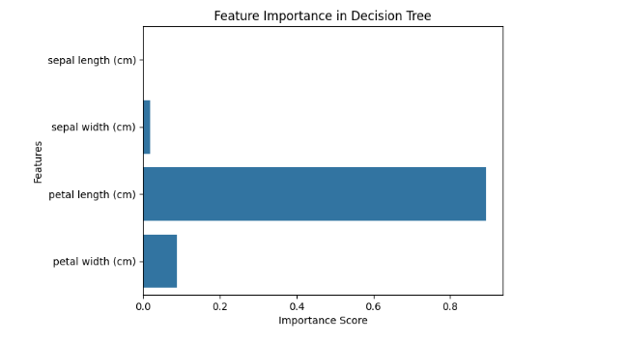
7. Hyperparameter Tuning:
Tuning Details:
- max_depth: Limited the tree's depth to prevent overfitting.
- min_samples_split: Increased the minimum number of samples required to split a node.
Results:
- The tuned model had comparable accuracy to the baseline model.
- Reduced tree complexity improved interpretability and generalization.

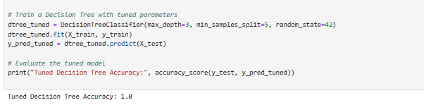
8. Confusion Matrix Visualization:
Observations:
- Setosa: Always classified correctly.
- Versicolor and Virginica: Misclassifications occurred due to overlapping feature spaces.
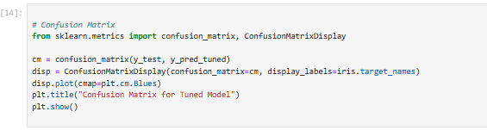
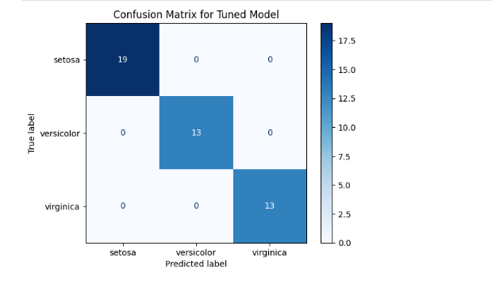
9. Key Takeaways:
- Decision Trees are powerful for small, interpretable datasets like Iris.
- Petal features dominate the classification task, reflecting their biological significance.
- Hyperparameter tuning balances complexity and performance.

10. Advanced Insights:
- Dimensionality Reduction: Removing less significant features (e.g., Sepal dimensions) simplifies the model.
- Ensemble Potential: Decision Trees can be scaled using methods like Random Forests and Gradient Boosting.
- Overfitting Detection: Visualization aids in spotting and mitigating overfitting risks.

11. Conclusion:
This tutorial demonstrated the power of Decision Trees for classification tasks. By combining interpretability with flexibility, Decision Trees provide a robust foundation for machine learning models. The notebook explored:
- Feature importance and how it aids model simplification.
- Visualization techniques for better understanding.
- Hyperparameter tuning to optimize performance.

References:
- UCI Machine Learning Repository: https://archive.ics.uci.edu/ml/datasets/iris.
- Scikit-learn Documentation: https://scikit-learn.org.
- Hastie, T., Tibshirani, R., & Friedman, J. (2009). The Elements of Statistical Learning.
- Breiman, L., et al. (1984). Classification and Regression Trees.
- Géron, A. (2019). Hands-On Machine Learning with Scikit-Learn, Keras, and TensorFlow.

